**Database Management System**



**Hospital Management System Project**

**Submitted to: Sir Shahid Nawaz**

**Submitted by: Saad Ahmed Jamal, Ali Raza, Fahad Tariq, Nukhba Tufail**

Dated: 31.12.2018

**User’s Guide:**

This application is programed in C++. You need to have a C++ compiler/environment in order to run this program. After a successful run, follow the guidelines to proceed. Use ‘Y’ character and “yes” string where required. In Manager mode, file handling is used for permanently saving the run time data. Then after changing the configuration settings of mysql workbench, use the below mention sql query for importing text file information into one of your table in your schema. The imported information can be further queried in sql environment like else.

**Overview:**

We had been working on creating a new, innovative and powerful database for Hospital Management System in C++. That database is to imported into mysql in the form of relational tables then. So that different queries and other analysis could be done easily.

We had created a hospital management plan earlier in C++ using tree data structure. This management system completely guides the user or patient from start to end where to go and what to do. This application had been made user friendly by introducing discounts and games. The total bill is then displayed in the end of the application. These all information regarding the patient (his biodata, his diseases, medicine and activities he performed) in hospital is kept in record,

**Importance:**

Keeping record of every person that visited hospital in hard form is quite difficult. For this database, it is made much easier. Applying some simple queries will help you achieve required information in seconds.

Following is the query used:

LOAD DATA INFILE "C:/ProgramData/MySQL/MySQL Server 8.0/Uploads/HospitalSafe.txt"

INTO TABLE persons

FIELDS TERMINATED BY ','

ENCLOSED BY '"'

LINES TERMINATED BY '\n'

IGNORE 7 ROWS;

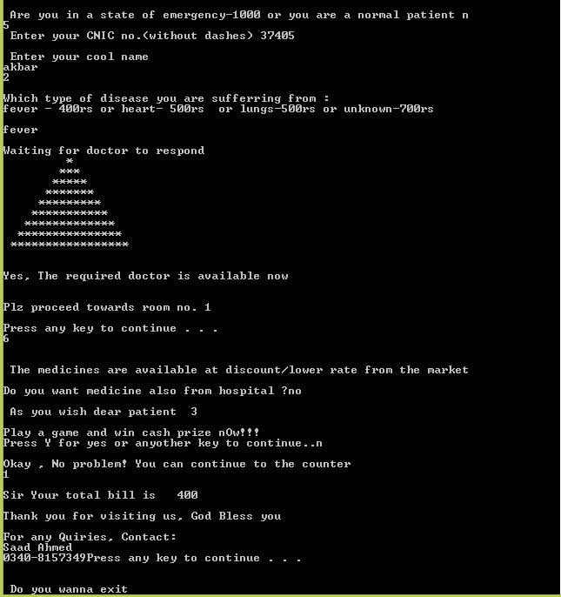



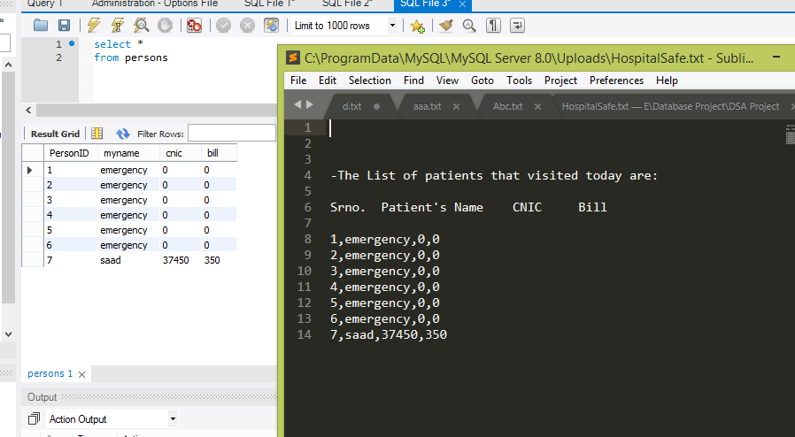

C++ output successfully saved in a database that can be further used in mysql.

**ER Diagram**

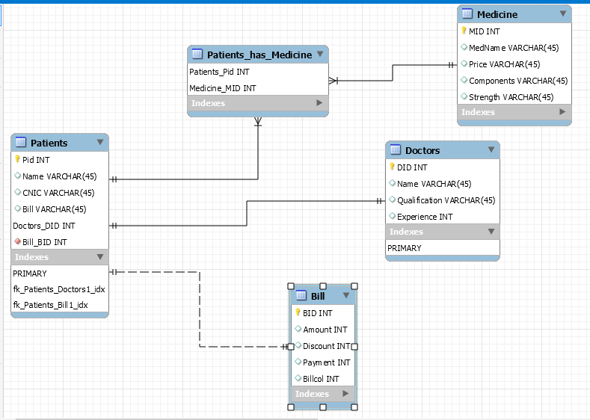

Some sql queries run over the table:

select myname, cnic as CnicNo, bill

from hospital.persons

where persons.PersonID =7;

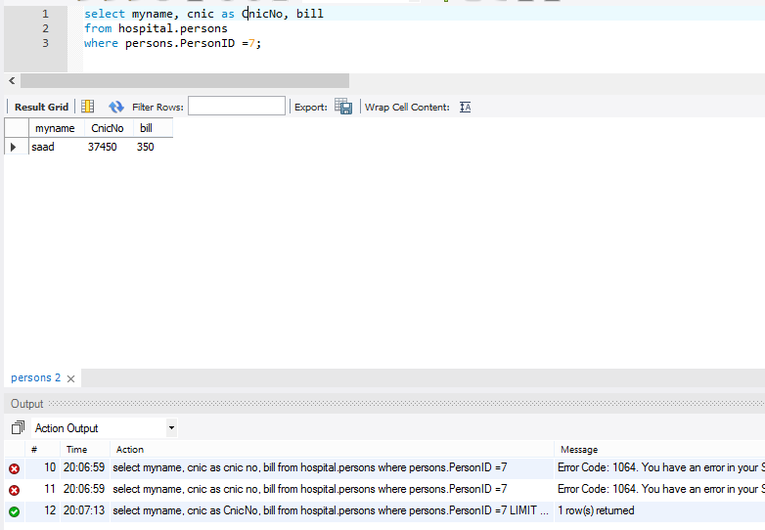

Query:

select *

from hospital.persons

where bill=0;

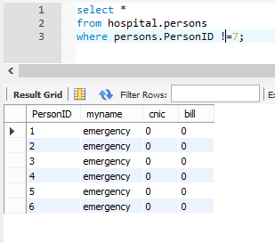

**Challenges:**

The main challenge that we faced was connecting C++ code to sql database.

For this we first tried to implement some code snippets in dev c++ but due to lack of libraries in dev version, this attempt failed. It could only be done with updated or modified dev version or by visual studio. Also it included a complex algorithm as well.

As an alternative attempt, we went for importing text file into mysql database using sql query that demands for termination key and line ending key which helps the compiler identify when the column is ending and when line is finished. This was quite difficult at first due to secure_file_priv function of mysql workbench that identifies it as unsafe act and do not allow it. For solving this problem, I have to go through the settings of workbench. And came up with the solution that the file through which data is being read is to be placed in a specific folder which is trusted by the environment just like we did in wammp. Placing file there resulted in removal of error and our this attempt was a success as database was correctly populated as intended.

Note:- The whole application has self-written code nothing is copied from net or any other source.